Cakes for the Queen of Heaven

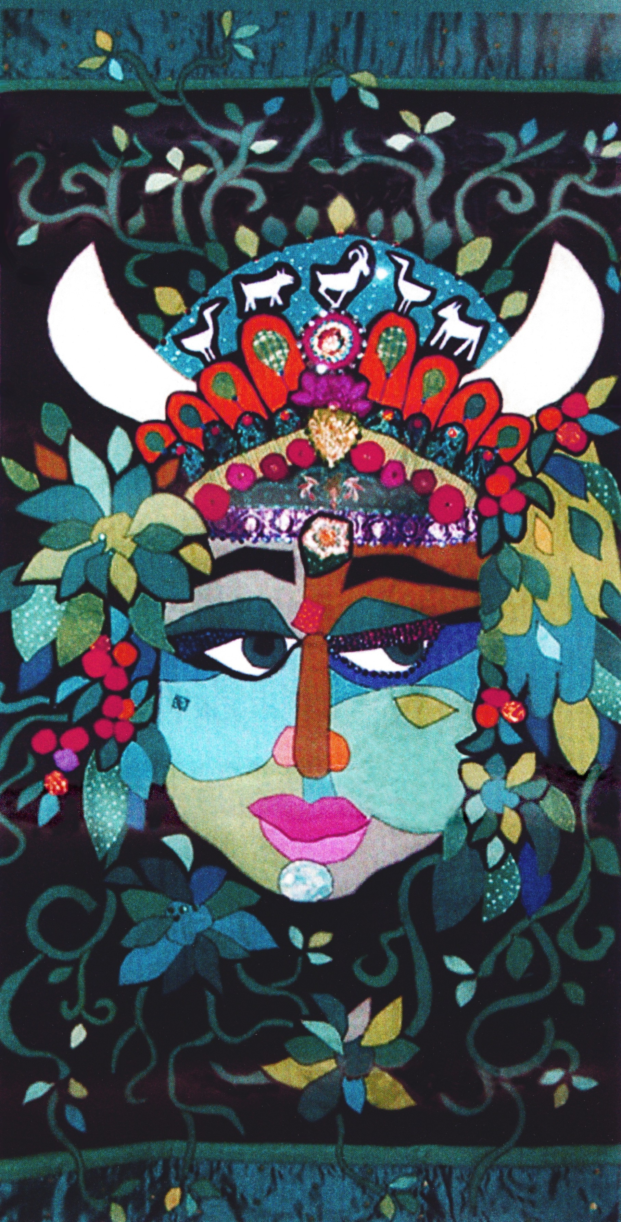
FACILITATOR TRAINING REGISTRATION FORM
Workshop fee is $30 for the day, 9 am to 5 pm.
Includes continental breakfast, lunch, supplemental resources, and childcare if requested.
Name:

Address:

City: State: Zip:

Home Phone: Cell Phone:

Email:

Please register at least 5 days in advance of the workshop date. Check the one you’d like to attend!
June 14 • St. Joseph, Michigan: Berrien UU Fellowship
June 21 • Chicago area - Oak Park, Illinois: Unity Temple UU Congregation
July 26 • St. Louis area - Kirkwood, Missouri: Eliot Chapel
November 15 • Peoria, Illinois: Universalist Unitarian Church of Peoria
November 22 • Milwaukee, Wisconsin: The First Unitarian Society, A Unitarian Universalist Congregation

I will need childcare for these children ages 6 and younger: (List children’s names and ages)

I have the following food allergies:

You will receive a confirmation from the Registrar with additional information such as maps. Links to church locations are on our website.

MAIL TO:
[name], Registrar
[address]
[city, state, zip]
[e-mail]
[phone]

Please make workshop checks payable to [sponsoring organization]. TOTAL ENCLOSED: $

CURRICULUM PURCHASE
PLEASE NOTE -- THIS WILL BE A SEPARATE TRANSACTION
I would like to pre-pay for a copy of the curriculum to pick up at the workshop (saves shipping costs).
CAKES PART I and II: Includes 11 sessions $75

ALSO RECOMMENDED: "She Calls to Us" CD by Carole Eagleheart includes many of the songs used in the curriculum.
You may want this if you like to learn songs by ear. $15

Please make curriculum checks payable to UU Women and Religion. TOTAL ENCLOSED: $

Cakes for the Queen of Heaven Train-the-Trainers workshops are a joint project of
the CMwD Women and Religion Committee and UU Women’s Connection (formerly CMwD-UU Women’s Federation.)
You may register online with a credit card! Here’s our website: www.cakesforthequeenofheaven.org
Be sure to check out our Cakes Facebook Group.... that's where we're talking about facilitator tips and experiences!

FROM: first class
_________________________________ postage
_________________________________ here
_________________________________

Cakes Facilitator Training
[name], Registrar
[address]
[city, state, zip]

_ _ _ _ _ _ _ _ _ _ _ _ _ _ _ _ _ _ _ _ _ _ _ _ _ _ _ _ _ _ _ _ _ _ _ _ _ _ _ _ _ _ _ FOLD _ _ _ _ _ _ _ _ _ _ _ _ _ _ _ _ _ _ _ _ _ _ _ _ _ _ _ _ _ _ _ _ _ _ _ _ _ _ _ _ _ _ _ _ _ _

_ _ _ _ _ _ _ _ _ _ _ _ _ _ _ _ _ _ _ _ _ _ _ _ _ _ _ _ _ _ _ _ _ _ _ _ _ _ _ _ _ _ _ FOLD _ _ _ _ _ _ _ _ _ _ _ _ _ _ _ _ _ _ _ _ _ _ _ _ _ _ _ _ _ _ _ _ _ _ _ _ _ _ _ _ _ _ _ _ _ _

Please fold this flap in, and secure all three sides with tape OR mail in envelope. Thank you!

